MBA 546 Case Report, Week 4
Topic: Salvage Cars
Due date: 24 September 2023
Submitted by Samyak Pratap Shah
Salvage Cars

Executive Summary
Aron operates a unique business wherein he refurbishes and sells Subaru Imprezas that once faced damages. To optimize the profitability of his venture, it's essential for Aron to set the right prices for these cars. Our goal was to delve into the factors that influence a car's price, like age, mileage, and specific features, and provide him with actionable insights.
Through our analysis, we discerned several patterns. Firstly, as cars age or accumulate more miles, their value tends to decrease. Secondly, Subaru Imprezas boasting premium interiors command a higher price in the market. Lastly, while it's a subtler influence, cars with alloy wheels seem to fetch a slightly higher price than their steel-wheeled counterparts.
Based on our findings, we suggest several strategies for Aron to consider. It would be prudent to ensure that the cars are consistently maintained, keeping them in optimal condition, as cars in better shape fetch a better price. Additionally, emphasizing the premium interiors can be a selling point, as such cars command higher prices. Providing potential buyers with options in wheel types can also be advantageous, allowing them to personalize their purchase. Gathering continuous insights about the cars, monitoring competitor pricing, and staying updated on market trends will also keep Aron ahead of the curve. Moreover, by offering a price range instead of a fixed price, he can cater to a broader customer base and adjust to market fluctuations. Above all, listening to customers, understanding their preferences, and taking their feedback seriously can refine his business strategy, ensuring he stocks cars that are in demand and prices them appropriately.
Our model serves as a comprehensive guide for Aron, and by heeding the insights and advice derived from it, he stands to make informed decisions, ensuring his car business remains competitive and aligned with what buyers are seeking.

Introduction
Aron has a business where he fixes and sells Subaru Imprezas that had been previously damaged. To make sure he's offering the right prices, we made a model using data on the car's age, mileage, interior, and wheel type. This report will show how these factors affect the car's price and give Aron some advice on pricing and managing his cars. We'll also test the model's predictions on three specific cars to see how accurate it is. By understanding all this, Aron can make smarter decisions for his business.

Data
Row Labels | Sum of Age | Sum of Mileage | Sum of Price
Normal | 116 | 704 | 274800
Alloy | 40 | 242 | 76400
Steel | 76 | 462 | 198400
Premium | 202 | 1047 | 365400
Alloy | 61 | 350 | 147500
Steel | 141 | 697 | 217900
Grand Total | 318 | 1751 | 640200

Looking at the table, Subaru Impreza is based on interior types, those with premium interiors have a higher combined value than those with Normal interiors. This means cars with better features tend to be priced higher. When considering wheel types, Subaru Impreza with steel wheels have been around for a longer time and have been driven more than those with Alloy wheels, but cars with Alloy wheels have a slightly lower total value.
In essence, Subaru Impreza in Aron's inventory differs in age, the distance they've been driven, and their total price depending on their features and wheel types. This info can help Aron decide how to price and manage his car stock.

Analysis
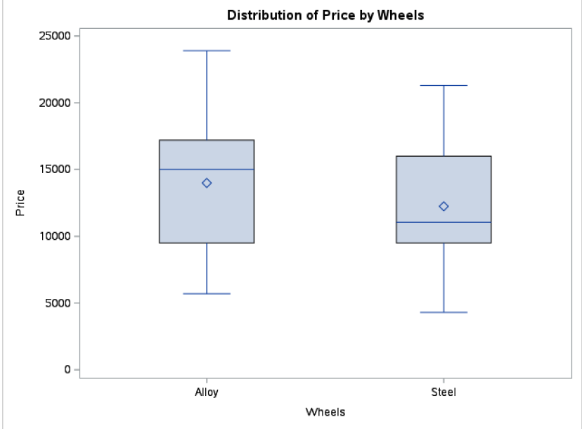
This is a description of the box plot distribution of price by wheels. Subaru Imprezas come with two types of wheels: Alloy and Steel.
For cars with Alloy wheels, the average price is around $12,795.65, with some cars being as cheap as $5,700 and others as expensive as $23,900. The range of prices for these cars is quite wide, with some cars priced far from the average.
On the other hand, cars with Steel wheels have an average price of about $12,009.09, with the cheapest being $4,300 and the most expensive reaching up to $21,300. The spread in prices for these cars is also considerable, but not as much as for Alloy wheels.
In short, while the average prices for both wheel types are quite close, Alloy wheels can be a bit pricier. Both types have a few cars that are priced quite differently from the average, which might be special editions or have other unique features.
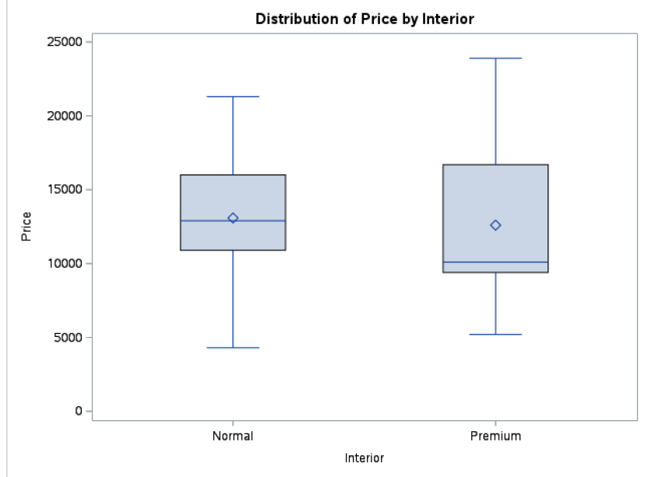
This is a description of the box plot distribution of price by interior.
Subaru Imprezas offer two kinds of interiors: Normal and Premium. They also come with different wheel choices: Alloy and Steel, and their prices vary based on these features.
The Alloy-wheeled ones average about $12,733 and can be as cheap as $5,700 or as expensive as $16,800. Meanwhile, the Steel-wheeled versions cost a bit more on average, around $13,227. Their prices vary more, starting from $4,300 and going up to $21,300.
Furthermore, cars with Alloy wheels are more expensive, averaging $14,750, and can be between $7,900 to $23,900. Those with Steel wheels are cheaper on average, at $11,468, with prices from $5,200 to $18,800. Basically, the mix of interior and wheels can change the car's price a lot. Some Premium and Alloy combo cars are especially pricey.
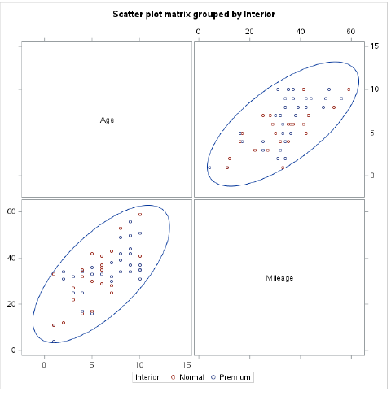
In a scatter plot grouped by interior type, here's what we see:
First, when looking at age against mileage, Premium cars aged 8-10 years show a mileage between 31,000 and 59,000 miles. The younger Premium cars, those 1-4 years old, mostly have lower mileages. In contrast, cars with Normal interiors that are 5-7 years old often have mileages between 16,000 and 42,000 miles. There aren't many older Normal cars aged 8-10 years in the data.
Secondly, when considering age against price, newer Premium cars are more expensive, going up to $23,900. But as they get older, their prices drop, though they still stay relatively high. On the other hand, newer Normal cars are a bit cheaper and their prices drop even lower as they age, hitting lows like $4,300 for the really old ones.
Lastly, for mileage against price, Premium cars with low miles fetch higher prices. But as they're driven more, their prices decrease. Normal cars follow a similar pattern: less-driven ones are more expensive, but their prices drop more consistently and faster with higher mileage. In short, while both age and miles drive down a car's price, Premium cars generally cost more than Normal ones at every age and mileage point.
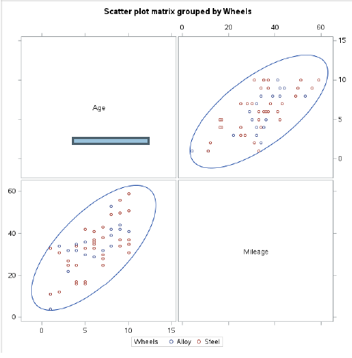
In a scatter plot focusing on wheel types, Alloy versus Steel, there are some interesting patterns to observe.
Cars with alloy wheels come in various ages and distances traveled. A 5-year-old car might have covered 30,000 or 36,000 miles. But, cars with steel wheels show different patterns, like a 5-year-old car covering only 16,000 miles.
For prices, newer alloy-wheeled cars can be costly, up to $23,900. But an older one might be much cheaper. Steel-wheeled cars, however, have varied prices based on their age. The key thing to note is the car's age and how much it's been driven affects its price more than the type of wheels it has.
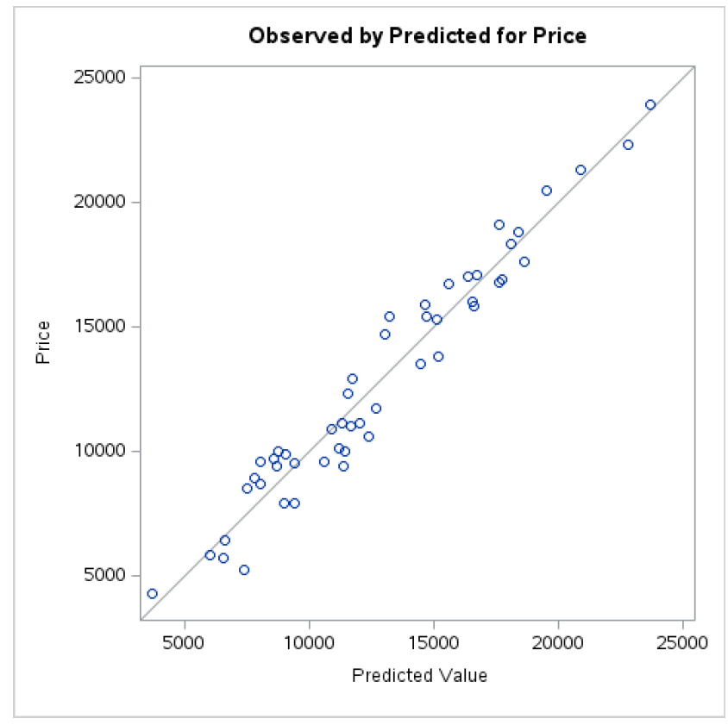
We made a model to predict car prices based on some factors. The factors we looked at are the car's age, how much it's been driven, the type of its interior (normal or fancy), and the kind of wheels (alloy or steel).
The model tells us:
- The older the car, the less it's worth. Every year reduces the price by about $1,232.
- The more a car is driven, the less valuable it becomes. Every 1,000 miles driven decreases its value by roughly $128.
- Cars with a regular interior are cheaper by about $1,300 than those with a fancy one.
- Alloy wheels can bump up the car price a bit, around $576 more than steel wheels.
Our model works well because it can explain about 95% of the price changes based on these factors. So, if you want to guess a car's price, you'd use these factors and their impacts as described. The basic idea is: the newer and less driven a car, with a fancy interior and alloy wheels, the higher its price will be.
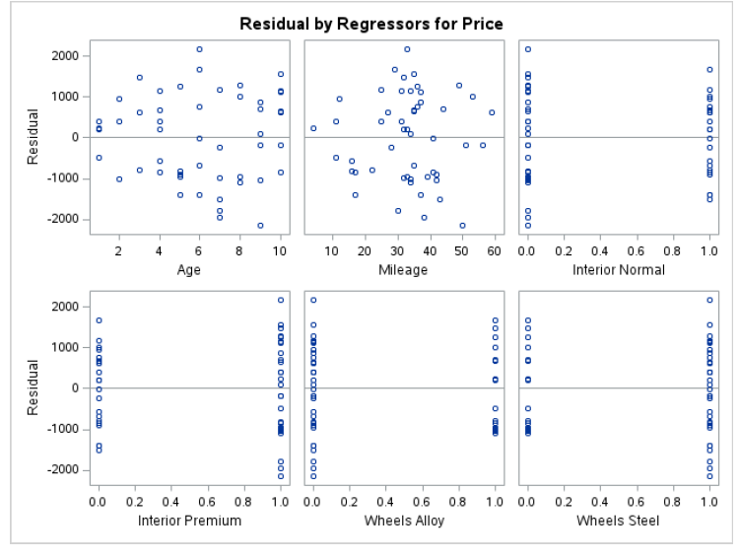
Let's break down how well our model does in predicting car prices based on different factors.
- Age: Our model says that as cars get older, their price goes down by $1232.37 every year. If our plot shows a pattern when comparing actual prices and the model's predictions based on age, then our model might be missing something about how age affects price.
- Mileage: We think that every extra 1,000 miles on a car reduces its price by $127.80. If there's a pattern in the differences between real prices and our predictions when looking at mileage, then our model's understanding of mileage might be too simple.
- Interior: Our model groups cars into two interior types: normal and fancy. It says regular interior cars are $1,299.92 cheaper. If one group's predictions are consistently off more than the other's, we might not fully get how interiors affect prices.
- Wheels: We've grouped wheels as either alloy or steel. Our model thinks alloy wheels add $575.95 to a car's price. If predictions for one wheel type are often wrong, our wheel-price relationship might need revisiting.
To sum up, by comparing our model's predictions to actual prices, we can see where it might be off and how we can improve it.
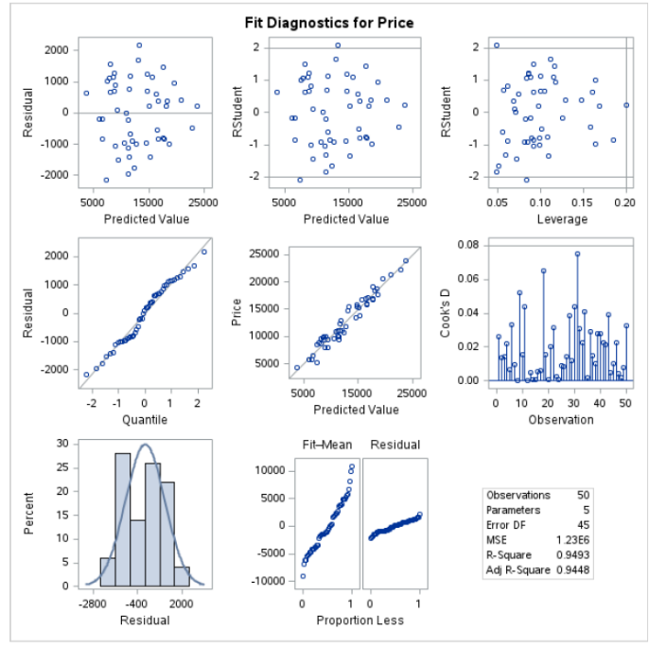
Assessing the Model:
1. Residuals vs. Predicted Values: When we compare our model's predictions to the real data, we want to see random differences, not patterns. Patterns suggest our model might be missing something.
2. Leverage vs. Residuals: This helps us spot any data points that might be dragging our predictions off course.
3. VIF (Variance Inflation Factor): If this number is above 10, it means our variables might be too interrelated, which is a problem.
4. Actual vs. Predicted Scatterplot: This shows how close our predictions are to the real data. We want our points to follow a straight line.
5. RMSE and R-Squared: The Root MSE tells us how accurate our model is, and the R-Squared shows how much of the price changes our model can explain.
6. Model Coefficients: These numbers tell us how each factor (like age or mileage) affects a car's price. Some have stronger effects, and some are more uncertain.
Using the Model to Predict Prices:
We have a formula that takes in details about a car and gives out a price. Here's what the formula predicts for three cars:
- Car 1: 8-year-old car, 42,000 miles, fancy interior, alloy wheels. The predicted price is about $10,405.41.
- Car 2: 5-year-old car, 30,000 miles, regular interior, alloy wheels. This car's estimated price is around $15,111.91.
- Car 3: 3-year-old car, 25,000 miles, fancy interior, regular wheels. Our model guesses its price to be approximately $18,760.47.
For a more precise price range for each car, we'd need more data.

Conclusions/Recommendations
We made a model to predict how much Subaru Imprezas might sell for, based on things like how old they are, how much they've been driven, and their features. Our model did a pretty good job, explaining about 95% of the price differences.
What We Found:
- Older cars and those driven more sell for less.
- Cars with fancier insides sell for more.
- Alloy wheels might add a bit to the price, but we're not too sure.
Advice:
- Look After the Cars: Cars that are in better shape and driven less sell for more. Regular check-ups can help.
- Fancy Interiors Help: Maybe think about making the inside of the cars nicer or letting people know more about models with cool insides.
- Talk About Wheels: Even if it's a small thing, let buyers choose between different wheels and tell them why each type is good.
- Gather More Info: The more we know about the cars and what buyers want, the better. Things like special features or how well it was looked after might help.
- Give Price Ranges: Instead of one price, give a range. This helps buyers know what to expect and covers any guesswork.
- Stay Updated: Keep an eye on what others are selling their cars for and what's happening in the market.
- Listen to Customers: What do they like? What don't they like? Their feedback can guide what cars to stock and how to price them.
This model is a handy guide for setting car prices. By following the advice, Aron's car business can set competitive prices and meet what buyers are looking for.

